**THE WHALE RIDER – Kungu Gachui.**

1. **The Novel: “The whale Rider” – Witi Ihimaera**

“**Although the Maori are patriarchal society it is the women who dominate the menfolk”** with close reference to Witi Ihimaera’s – “The whale Rider” write an essay to show the validity of the above statement

**Introduction**

It is ironical that a society that is patriarchal in nature has its women taking charge of situations. In the Novel, **The WhaleRider** the women characters come out stronger that the men

* Muriwai, Nani flower’s ancestor, takes charge of a cause that is in danger of capsizing and saves herself and the men crew in it.
* Nani flowers comes out stronger in her arguments with her husband, Koro and always comes out victorious in the many arguments they have
* Nani takes charge of Kahu’s birth cord and ensures it is buried at the right place a task normally performed by men.
* Nani at one time pushes Koro out of bed and Koro sleeps on the floor – something demeaning for a man who is chief of the Maori
* Rehua, Porourangi’s wife is potrayed as wise and decisive, names her daught Kahu and requests that her birth cord and after birth be buried at Whagara,. This foresight ensures Kahu’s survival and inheritance of the Maori chieftain
* Ana and not her husband Porourangi is the one who decides that Kahu should come and live with the family instead of being raised by her maternal grand mother.
* Kahu excels academically beating boys at school

She is best in Maori language and culture

She retires the cared stone from the deepest ocean – while boys that Koro had been training fails to.

* Kahu is able to communicate with the whales and dolphins something that Koro tries and fail and therefore she manage to rescue the whale as the whale rider and saves the tribe she therefore becomes the next leader of the Maori people.

**Witi Ihimaera, The Whale Rider**

“Ihimaera uses the novel to show that **certain stereotypes about women are quite unnecessary”** Write an essay to show how certain negative beliefs about women are discredited in The Whale Ride.

Introduction

Since time immemorial the woman has been regarded as a weaker sex (gender). Society has been having certain stereotypes about women. For instance there are certain jobs or even foods that women are not allowed to have. This is an unfortunate state of affairs which has been overtaken by events and is unnecessary as outlined below.

(Accept any other relevant introduction)

Content – points to consider

* Women in Witi’s society were being kept away from the training of cultural ways which were considered sacred and for men. Kahu however proves then wrong when she becomes interested in the Maori culture and is destined to lead her people. She becomes the first woman to go against this stereotype which for years had placed woman in a place of disadvantage.
* Women were not allowed to assume leadership positions in Witi Ihamaera’s society. The chieftaincy was passed on from the eldest son to the eldest son of the next generation. This went on until kahu breaks the monotony. Kahu shatters this belief for she is determined to become the leader of her community after Koro Apirana. Nani Flower’s ancestor, Muriwai was one of the greatest women chiefs in her time whose blood, Nani believes, throbs in Kahu’s veins. Unlike other traditionalists, Nani Flowers believe Kahu can be a leader.
* It was expected that it was only men who could undertake certain tasks like making the ancient bull whale return to sea. But to the surprise of everyone, when all men fail, it is Kahu who comes to the aid of the community and saves it from perishing. This was against the stereotypes.
* Koro Apirana had a low opinion of Kahu.

He is not happy when his grandson’s first born turns out to be a girl (Kahu). He so desperately wishes for a male child as a first born so as to be the heir to inherit (take) the seat of Porourangi. Unfortunately, it does not work despite all the efforts and Kahu, a girl, emerges the chosen heiress and takes up the leadership of Porourangi.

(*Accept any relevant point)*

1. The Novel

Witi Ihimaera’s ‘The Whale Rider’

‘The world would be a better place **if women were given equal opportunities**.” Basing your illustrations on Witi Ihimaera’s ‘The Whale Rider,’ argue in favour of this assertion.

**Introduction**

Discrimation against women is baseless and unwarranted. A society that discriminates against them wastes a lot of potential and subjects the women to unnecessary suffering. In Witi Ihimaera’s *The Whale Rider* this is clearly seen through Kahu and Nani Flowers.

**Content**

Nani Flowers comes to the aid of Kahu when she is born. Koro Apirana is so desperate for a baby boy that when a girl is born he simply brushes her aside saying ‘ I have nothing to do with her.’ For the burial of the afterbirth, it takes Nani Flowers firmness to have it buried in her paternal home. This is despite opposition from Koro Apirana. Thereafter, she protects her from Koro who keeps growling at her. She therefore presents herself as a voice of reason.

Secondly, Kahu emerges the best in the school break-up ceremony despite all odds. She writes a winning speech in the Maori language. This is similar to the cultural preservation that Koro has been working for.

Kahu also comes to the rescue of the community when its livelihood is threatened. This is the case when the whales come to the shore to protest the invasion of their kingdom. After the effort of all the men bore no fruit, a mere girl, who happens to be the subject of Korosis the one who makes the whole difference.

To the utter surprise of Rawiri and the boys, there is a white lady wading off whale hunters who are cashing in on the stranded whales. Her wails and call for help draw the boys to her and together they manage to save the stranded whales.

Lastly, symbolically, the Whale Mother comes out as a voice of reason when she convinces the Bull Whale,that the rider is not Kahutia Te Rangi. This is despite the Bull Whale's conviction. So, when it turned out that the rider was really a girl, the Whale Mother takes the day as a female.

NB: ACCEPT ANY OTHER RELEVANT POINTS THAT PORTRAY THE WOMAN POSITIVELY.

**Conclusion**

From the discussion above, it is sufficient to conclude that the woman occupies a special position which has been undermined for a long time.

Mark 3:3:3:3 = 12

Introduction = 2

Grammar = 4

Conclusion = 2

Total 20

‘**The society looks down upon women.**’ Write an essay in support of this statement drawing your illustrations from The Whale Rider by Witi Ihimaera.

* The society looks down upon women. Support the statement.
* Women cannot be trusted with leadership.
* Pai – 12 year old girl born as a twin but her brother died. Her brother was expected to be chief to continue to lead the next generation on from their grandfather Koro.
* Koro does not believe that Pai should bear the name of the great legend ‘Paikea the Whale Rider.’
* Koro also thinks of Paikea as being worthless and he does not want Pai because she is female. Pai considers herself as being destined to be the next chief because she is a direct descendant of Paikea.’
* Traditional expectations and inclinations make Koro to choose to pick a male from the tribe to be chief, Koro in the beginning is unable to accept Pai because of his own traditions and his tribe’s 1000 year old tradition – that every first male born is the new chief in their generation.
* The society’s bias towards the male child – Koro would rather have Pai die and her twin brother live. Koro states that he is only there for the boy because his first anote is ‘where is the boy?”
* Koro wouldn’t even acknowledge his granddaughter Pai is lying next to the deceased boy – Koro commands that she be taken away but the girl squeals and cries demanding for her grandfather’s acknowledgement.

*Accept any other relevant point.*

*Expect 4 well illustrated points.*

*Mark 3:3:3:3 = 12 marks*

CONCLUSION

* 1. A summary of the given points.
  2. An opinion that sums up the points.
  3. Accept any other relevant conclusion.
  4. Language (4mks)

1. ***The Whale Rider*** ***(20 marks)***

**Both boys and girls have equal rights to leadership in the society**. Write an essay supporting this statement basing your answer on Witi Ihimaera’s novel,

**Intro: Any but appropriate**

1. The traditional expectations of the society that leadership is handed down from the father to the eldest son excludes girls from assuming leadership. Yet Muriwai proved this belief wrong for she was one of the greatest chiefs of her people.
2. The disappointment Koro Apirana has at the birth (and his opposition to be given a male’s name) of Kahu is unnecessary because it turns out that Kahu is the chosen one that he has been searching for all along, to take the mantle of leadership.
3. When the community requires strong leadership, it is the women who upstage the men in leading the way. Nani Flowers ensures that Kahu’s afterbirth and birth cord are buried in front of the tribe’s meeting house, which bears the statue of Kahutia Te Rangi. This enhances the community’s connection to the ancestors.
4. The boys fail to retrieve Koro Apirana’s carved stone but Kahu, effortlessly goes into the ocean and brings it back. She even communes with nature.
5. The entire population of the male in habitants of Whangara fails in their attempt to coax the ancient bull whale back to the ocean, but Kahu manages to do so. As a result, she is accepted by Koro who calls her the best grandchild in the entire world.

Any other relevant and justified point

**The Novel**

Witi ihimaera, The whale Rider

‘**Societies use traditions to justify their suppression of women**.’ Using illustrations from Witi Ihimaera’s the Whale Rider, write and essay supporting this statement.

**THE NOVEL: THE WHALE RIDER**

Introduction (2mks)

- it is indeed true that society uses cultural practices to deny women opportunities. This is clearly brought out in the novel ‘the whale rider.’ or

- contextual or general introduction highlighting implications of gender disparity to women.

(Accept any other relevant introduction)

Content (12mks)

Ci the naming of the girl after her male ancestor Kahutia i.eRangi is vehemently opposed by her great grand father Koro Apirana, aha thanks that it would be a contemptuous act since kahu is a girl , who was believed to be of no use in this male dominated society. He felt naming the girl-child afther the founder of the tribe was belittling kahutiai.erangi’s prestige.(pg 14-16)

Cii in this text the tradition do not allow a girl to take over a leadership mantle. The news of kahu annoyed koro so much that he started to desperately search for someone in fact a boy – a man that will succeed him.

Ciii kahu’s straggle to assert her leadership potential was brutally rejected by the traditions through koro. The girl naively bites koro’ toe , searches and obtained his cover stone and addition crayfish that the boy had failed to retrieve did not appeal to him because she is a girl.

Civ in this society the traditions restricts woman from the attending men’s lessons. Koro is upset when kahu intrudes into the room where lessons on language were going on.

Cv traditionally it is a taboo for a man to get in contact with kahu. The fact that porourangi fails to protect the girl because of the traditional order.

Cvi the culture practice had a bad effect to woman in school. Despite kahu doing well by topping in every item in school, koro fails to attend the ceremony.

(Accept any other relevant point)

Expect any 4 well developed points, mark 3:3:3:3= 12mks

Conclusion (2mks)

* In conclusion , woman are never allowed to express themselves in this society. They have to fight like the girl kahu.or
* A recap of the discussed points or
* An opinion that sums up the essay

Language (4mks)

**The Novel** (20mks)

‘The Whale Rider’ by Witi Ihimaera.

Point out **four aspects of Maori culture portrayed** in The Whale Rider and relate them to cultures of East Africa communities.**The Novel**

**Introduction**

* Aspects of the Maori culture portrayed are belief in ancestors, relationship between humans and wildlife, gender, discrimination and attachment of places of birth / origin.
* The people of Whangara have a strong belief in their ancestor, Paikea who came riding on a whale. E.A. believe in legends who founded their communities e.g. Gikuyu and Mumbi.
* The Maori people believe that their lives and those of creatures are closely connected. If the whale lives, they live and vice versa. E.A. have animals they relate to as their ‘relatives, totems or clan symbols.
* Gender discriminations is blatant in the Whale Rider. Koro Apirana rejects her granddaughter, Kahu. In E.A., sons are regarded as the rightful heirs and inheritors of family line and property.
* Attachment of places of birth or origin is seen in the Whale Rider where Kahu’s umbilical cord in front of the meeting house. In E.A. there is also a desire by people to be buried on one’s ancestral grounds.

**Conclusion**

* Aspects of Maori culture are closely similar to those of E.A. communities(2mks)

Expect any three well illustrated points

Mark 4:4:4 = 12 marks

Language = 4 marks

**The Novel: Witi Ihamaera:** “The Whale Rider”

Using illustrations from **Witi Ihimaera’s** “**The Whale Ride**r”, write an essay to show **how “Leadership is passed from generation to generation”**  (20Marks) .

How leadership is passed from generation to generation in Maori community.

It is customary for leadership of Maori people to pass from male descendant to the next.

The first born child of the heir apparent ought to be a boy for this lineage to progress.

* Porourangi’s siring of daughters in succession is viewed as ill-luck and that is the reason for koro Apirana’s anger, he says he does not want anything to do with the girl Kahu.
* This is dearly a patriarchal society that believes in the supremacy of boys over girls or men over women.

When Kahu is born, it is evident that her great grandfather expected a boy to inherit leadership of the community.

* He becomes disappointed when a girl is born and rejects her
  + He is looking for a male heir to the chief truancy and will not settle for a girl.
* The birth of another girl-child to Porourangi with his new wife Ana, does not make things any better. Instead, koro Apirana becomes obsessed with looking for a boy to inherit the chieftaincy. He even begins to look into other royal families to get the chosen one.
* Leadership in Maori community is purely hereditary and the mantle is passed from the eldest son to the eldest son is disintegrating slowly when Kahu becomes the chosen one.
* Though there is resistance by koro Apirana that a girl (female) should not take over leadership and insists on getting a boy to inherit the chieftaincy, Kahu finally inherits the leadership of Maori community.

Introduction - 2mks

Body / content - 12 mks (3: 3: 3: 3)

Conclusion - 2 mks

Language - 4 mks

**The Whale Rider**

**The natural and the supernatural are in mutual co-existence** in The Whale Rider by Witi Ihimaera. Write an essay in support of this statement.

**.c**)**INTRODUCTION**

Most communities believe in the harmonious co-existence between the living and the departed between the humans and other creatures whom they are closely linked. In Witi Ihimaera’s novel, The Whale Rider this is quite evident.

*Any other relevant introduction 2mks*

**BODY**

* The spirit of the ancestor Kahutia Te Rangi – the Whale Rider lives in eh little girl / Kahu.
* The ancestors are able to communicate with whales and other animals.
* When the whales are stranded, they have to be sung to and talked to in order to move back to the sea.
* Every activity including fishing is preceded by a sacrifice to the gods.
* As some whales are dying, the other whales make mourning sounds like humans and he death of the ancient bull whale will mean the death of the whole community.
* While other people are butchering whales, some members of the community come up strongly to defend the whales because of their sacred origin.

*Accept any four well illustrated points mark 3: 3: 3: 3*

**Conclusion** (2mks)

From the above illustrations, we see that both the natural and supernatural co-exist / are in harmony.

*Accept any other relevant conclusion.*

**The Whale Rider**(by Witi Ihimaera)

**“What a man can do, a woman can do even better”.**

Write a composition to support this statement basing your discussion on the novel,

**) OPTIONAL TEXT: WITI IHIMAERA: The Whale Rider**

**Introduction**

The society in the Whale rider is clearly a patriarchal one. It believes in the supremacy of boys over girls / men over women. When Kahu is born, her great grandfather is not excited that the child born is a girl. He keeps telling her that she is of no use to him. **But she grows to prove herself true to her calling**.

- From her childhood Kahu is marked and shows the potentials of a leader. This is not so with boys of her age. But there are few who cannot recognize this. Like her great grandfather Koro – who believed that the next chief must be male as has been the tradition.

- Kahu is a bright and capable child. She proves herself up to any task. She is willing to learn about her culture and steals herself to hear Maori lessons – traditionally meant for men /boys. Here she learns better than the boys do.

- Kahu excels at school in both academics and cultural events.

- She has talent and skill. She is capable of doing what no one else in this community can do; she speaks to the Whales – this makes her special even above male counterparts through Koro, her great grandfather can’t see this.

- The author believes that children, regardless of gender, should be mentored into leadership as leadership comes from both men and women and this fact ought to be accepted by all.

**Conclusion**

Governance systems which are under the control of men exist across the world. Cases of women rising to leadership are still few as women are still denied the opportunities to realize their full potential as human beings. Witi Ihimaera explores the idea that women can hold positions of responsibility and do it well.

- Society should accept women as equal in ordinary life and support them.

**Witi Ihimaera: The Whale Rider**

**Compare and contrast the character of Koro Apirana with that of Nani flowers**

**Introduction:**

To compare is to pinpoint the similarities and to contrast is to identify the differences which exist between Koro Apirana and Nani flowers. (2marks)

**Body**

**Similarities**

**i) They are both loyal to their family and tribe.**

Koro Apirana goes to great lengths to protect and identify members of the tribe by starting school sessions to teach boys and men the Maori customs and language. He fiercely protects the age old tradition of only boysinheritng the mantle of leadership. He rejects Kahu, his great grandchild, because she is a girl.

Nani flowers love for Kahu is evident in the things she does to ensure that she remains among her people. She buries her birth cord in Whangara near the meeting house in the sight of the stature of Kahutia Te Rangi the founder of the tribe.

**ii) They are both stubborn**

Koro Apirana adamantly refuses to love Kahu because he prefers a boy child to inherit the chieftaincy from Porourangi. He does not allow her to participate in the lessons he gives the boys on the wisdom of the tribe. He even fails to recognize that Kahu is the chosen one because he is blinded by chauvinism.

Nani flowers also stubbornly refuses to let Koro Apirana have his way where Kahu is concerned. She does all she can to ensure that Kahu remains among her people. She cites her Muriwai lineage when Koro Apirana thinks she is stubborn and uncooperative.

**iii) They are both loving**

Nani Flowers loves Kahu right from the beginning without caring whether she is a girl. Koro Apirana however, loved her at the end of the story when it is no longer in doubt that she is the chosen one.

**Differences**

(i) Nani flowers is humorous and full of life while Koro Apirana is said to be grumpy. Nani’s threat to divorce Koro Apirana is comical because she does not carry out her threat. She chases after her husband when he goes out to sea to sulk and calls him endearing names as she does so.

* Koro Apirana, on the other hand goes not to sea to sulk whenever he feels angry. He also growls at Kahu whenever she shows up at the door of the meeting house.

ii) Nani Flowers supports the girl child as a leader. She does everything in her power to support Kahu. For example, she buries her birth cord in Whangara to ensure she is close to her people.

* Koro Apirana is steeped in traditions and does not support the idea of girls taking up of leadership positions. He refuses to see Kahu as a possible leader of the tribe even when the signs are there.

**Conclusions**

It is evident that inherent similarities and dissimilarities exist between Nani Flowers and Koro Apirana (2marks)

Expect 2 well brought out similarities and 2 differences

Mark S: 3: 3 = 6marks

D: 3 : 3 = 6marks

Grammar = 4 marks

**3.**  The Whale Rider (20 marks) **Witi Ihimaera**, The Whale Rider

“**Certain stereotypes about women are quite unnecessary**.”

Write an essay that outlines how certain negative beliefs about women are discredited in the ‘The *Whale Rider*’ by *Witi Ihimaera*. (20 marks)

Introduction: (2mks)

* Candidate should demonstrate general understanding of stereotypes.
* Link to the text.
* Allow any relevant introduction tied to the question and well explain.

Content (12mks)

- Women being kept away from the training on cultural ways which are considered sacred and for men. Kahu proves them wrong when she becomes interested in the Maori culture and is destined to lead her people.

- Women are not allowed to assume leadership positions in the community. The chieftaincy is passed on from the eldest son to the youngest son. Kahu shatters this belief for she is poised to become the leader of the community. Nani flower’s ancestor, Muriwai was one of the greatest women chiefs in her time whose blood, Nani believes, throbs in Kahu’s vein.

- When men fail to make the ancient bull whale return to sea, it is Kahu who comes to the aid of the community and saves it from perishing.

- Even Koro Apirana is desperately looking for a male heir to the seat of Porourangia girl emerges as the chosen one.

(4 well illustrated pts. 3mks @ - 12mks)

Conclusion – (2mks)

* Summary of the points illustrated in the body.
* Should be relevant and tied to the content grammar. (4mks)

Marks

Introduction – (2mks)

Body 3:3:3:3 – (2mks)

(Expect 4 well illustrated points)

Conclusion – (2mks)

Grammar

(Marks should be tied to the points) – (4mks)

Total – (20mks)

**The Novel**: The Whale Rider (20 marks)

It **requires a strong character to survive in a male dominated world**. Assess the truth of this statement with reference to Nani Flowers in “The Whale Rider” by **Witi Ihimaera.**

**Introduction**

- Nani Flowers is portrayed as a character who can not be put down under any circumstances. In a community that is patriarchal in nature, she opts to defend herself and other females in her household and society.

- She goes out of her way to defend her great grandchild against Koro Apirana’sprejudice. She defends Porourangi’s decision to name her ‘Kahu’ despite it being a man’s name. She hits the narrator for overworking the girl and taking her to the moves. She also refuses to allow Koro Apirana to alienate the girl and encourages Kahu to pester him for attention. Despite her obvious disapproval of Koro Apirana’s mannerisms, she truly loves him and fondly calls him ‘Old Paka’.

- She is assertive, and independent minded as a wife and grandmother. She tells Koro Apirana occasionally that she will divorce him to marry Waari if he continues to annoy her. She pulls his boat back to the beach after he sulks after quarreling with her she insists on bringing back to the community. Kahu’s afterbirth and birth cord despite Koro Apirana’s opposition. She demands that women should be allowed to participate in meetings and saving the ancient bull whale.

- She is strong-willed and courageous. She says she belongs to the Muriwai people whose fierceness is legendary. Indeed Koro Apirana agrees with her and says her Muriwai’s blood is too strong thus it has led to the birth of a girl as an heir in the family. She defends the decision to name Porourangi’s child, Kahu and quarrels and challenges Koro Apirana on almost everything. It is said she is always stepping out of line.

- She is foresighted. She is able to notice the extraordinary abilities and qualities in Kahu. That’s why she buries her afterbirth and birth cord in front of the tribe’s meeting house. She encourages the girl to attend the men’s meetings by threatening Koro Apirana whenever he sends Kahu away. She notices that Kahu is no ordinary girl while she is retrieving the curved stone from the floor of the ocean. She also notices that the girl is communicating with the Dolphins and she bids her time waiting for the right signs of what is to come.

Should have a conclusion, the candidate should tie up his/her argument using a short paragraph.

(Use the format of making question 2 to mark this one).

**The Novel** (20 marks)

*Witi Ihimaera,* ***The Whale Rider***

**Kahu faces a lot of rejection but eventually saves her people**. Write an essay expounding on this rejection experienced by Kahu.

(a) Introduction

Most people who volunteer to save the society encounter obstacles and hardships on the way. One of these challenges is one of rejection not only by the society but also by those close to them. This makes their work quite difficult. In The Whale Rider, Kahu is rejected right from birth even though she is the one who finally saves her people.

(Accept any other relevant introduction, 2mks.

Should only be in the first paragraph.

Do not accept a mere definition or restatement of the question.)

Content

(i) She is rejected from birth for being a girl. The grandfather rejects her when the phone call reveals that she is a girl. “*A girl*”, *Koro Apirana*, our grandfather said disgusted. “*I will have noting to do with her. She has broken the male line of descent in our tribe*.” He even blames his wife for Kahu’s birth. “*It’s your fault. Your female side was too strong*.” P10.

(ii) Her name is rejected. She is given a boy’s name. Kahutia Te Rangi is not only a man’s name but it is the name of the ancestor of their village. Koro Apirana feels that naming a girl child after the founder of their tribe is belittling Kahutia Te Rangi’s prestige. P14

(iii) Her birth causes cultural conflict. Koro Apirana cannot reconcile his traditional beliefs about Maori leadership and rights with Kahu’s birth. By Maori custom, leadership was hereditary and normally the mantle of prestige fell from the eldest son to the eldest son.

(iv) She is rejected as an orphan particularly by Koro Apirana. Porourangi brings Kahu’s mother back to the village where the funeral was held. When Rehua’s mother asked if she and her people can raise Kahu, Nani Flowers objects strongly.

(v) She is rejected when she comes for holiday. She is put in Koro Apirana’s hands but he says no though it is surprising how Kahu and Koro Apirana resemble each other with the only difference being that she loves him but he does not love her. When he gives her back to Nani Flowers, she starts to cry, reaching for him but he turns away and leaves the house. P25.

Expect any 4 well developed areas. Mark 3:3:3:3. Total 12 marks.

Kahu’s rejection must clearly be seen; if not mark out of 2 for each point.

Grammar and presentation score pegged to content score as shown.

(b) Conclusion

It is indeed true that ‘*prophets are rarely recognized in their homes*.’ This is true even from religious writings but the same people become saviours of the very same communities who rejected them.

Accept any other relevant conclusion 2 mks

Should only be in the last paragraph.

Score should be tied to the content score as shown in question 2.

) THE NOVEL

Witi Ihimaera - The Whale Rider:

Drawing your illustrations from the Whale Rider by Witi Ihimaera, write a composition entitled

"**Gender discrimination is sometimes proved wrong**". (20 marks)\

**The Novel ‘The Whale Rider’ – Witi Ihimaera**

Drawing examples from the novel**, show how women are discriminated against in the Maori society**

Q4 WHALE RIDER

Introduction – 2 marks

It must introduce the question appropriately it can be either be generalized or contextualized.

* 1. When Koro Apirano learns that he has a first born great grand daughter, he comments that he has nothing to do with her. He is disgusted because the girl had broken the male line descent in their tribe. He expected a boy who would be next chief because women were not traditionally expected to hold positions of chieftain.

He says that Kahu won’t be any good to him ‘No good. I won’t have anything to do with her” that Porourangi had better have a son next time. When Nani Flowers brings out the subject of Kahu, Koro Apirana compresses his lips crosses his arms, turns his back on Nani and looks elsewhere.

* 1. We are also told that the love which Kahu received from koro Apirana was the sort that dropped off the edge of the table like bread-crumbs after everybody else had a big meal. This shows that women are considered inferior men in the society.
  2. Koro Apirana excludes women from instruction in his school. This is clearly noted when Kahu has to sneak or just stare in at the boys as they receive instruction. When he finds her eavesdropping, he grows at her and sends her packing.
  3. When Kahu openly embraces Koro Apirana, he cannot reciprocate the love. He feels embarrassed and ashamed. We are told that he stood there thunderstruck looking for somewhere to hide. He is also not comfortable with Kahu calling him Paka and he tries to persuade her to call him ‘Koro’ but she won’t stop.
  4. When Koro Apirana is told by Nani flowers that he should not discriminate against women any more, he answers that he doesn’t give a hang about women and they haven’t got the power. We also learn from Kahu that it is considered a waste of time for a girl to go to university.
  5. We learn also that women are discriminated against in the Maori community this in the case of MihiKutukutuku a big chief who descended from Aparui, she was once ordered by a chief to sit down because women were not allowed to stand up and speak on sacred ground.
  6. Another instance of discrimination against women from the traditional activities of the Maori tribe is where we are told that fishing is only done by men because it is considered a sacred activity and men are considered to be sacred.
  7. Koro Apirana has started a school for boys and discovered three sons from royal bloodlines to whom he intends to pass the mantle of knowledge.

He keeps on chasing Kahu away from the boys’ school meetings and at one incident he hurls her away and cautions Nani to keep her away from the meeting house.

* 1. In the chieftain test that involves people diving into deep water to retrieve a curved stone dropped there by a priest, only men are involved.

Conclusion – 2 marks

This must be a summary of the main argument(s)

Marks distribution/allocation

Introduction – 2 marks

Content (any four well ill. 3 marks) 12 marks 3:3:3:3

Linguistic competent – 4 marks

(TOTAL 20 MARKS

**THE NOVEL: Witi Ihimaela’s -** *The Whale Rider*

Using the novel,*The Whale Rider*by Witi Ihimaela, **show how traditions prevent women from contributing towards society’s development.**

1. The novel: The Whale Rider.

Write a story that portrays **Kahu as a child of destiny from birth in the novel**The Whale Rider by Witi Ihimaera

1. **The Novel**

‘The whale Rider’ Witi Ihimaera

**Both boys and girls have equal rights to leadership in the society**. Write an essay supporting this statement basing your arguments on the novel. “The Whale Rider”.

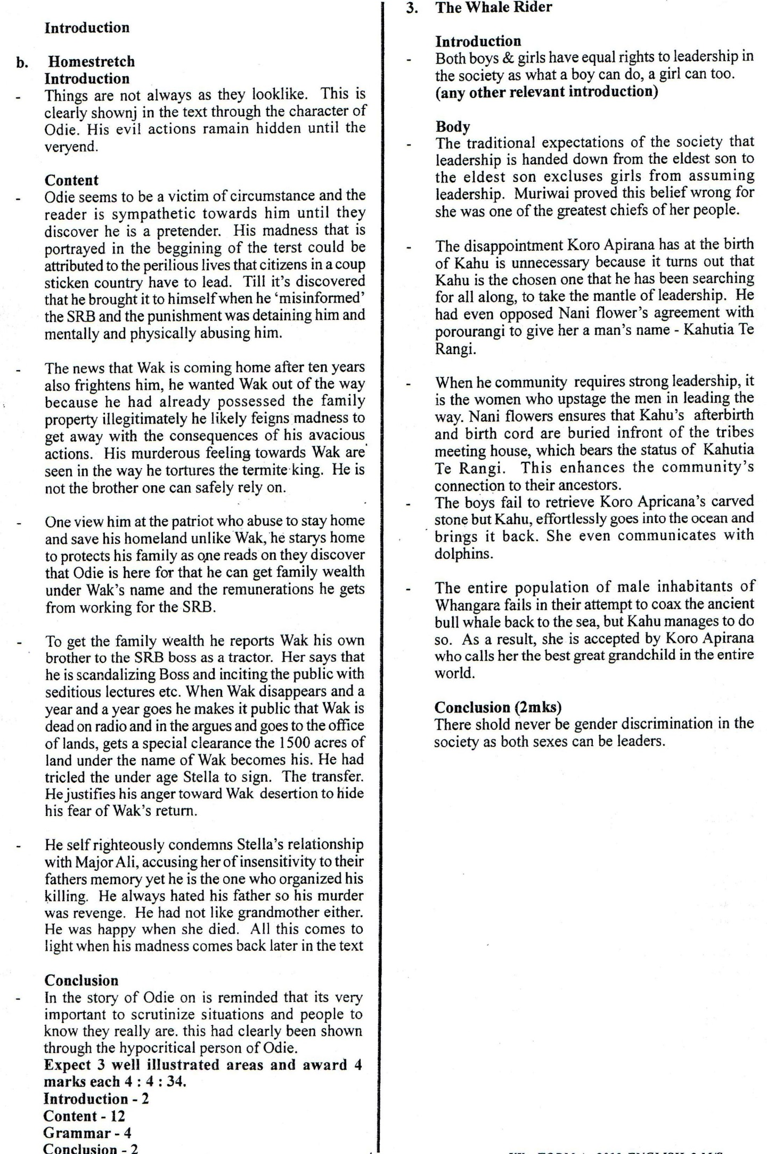

Witi Thimaera – The Whale Rider

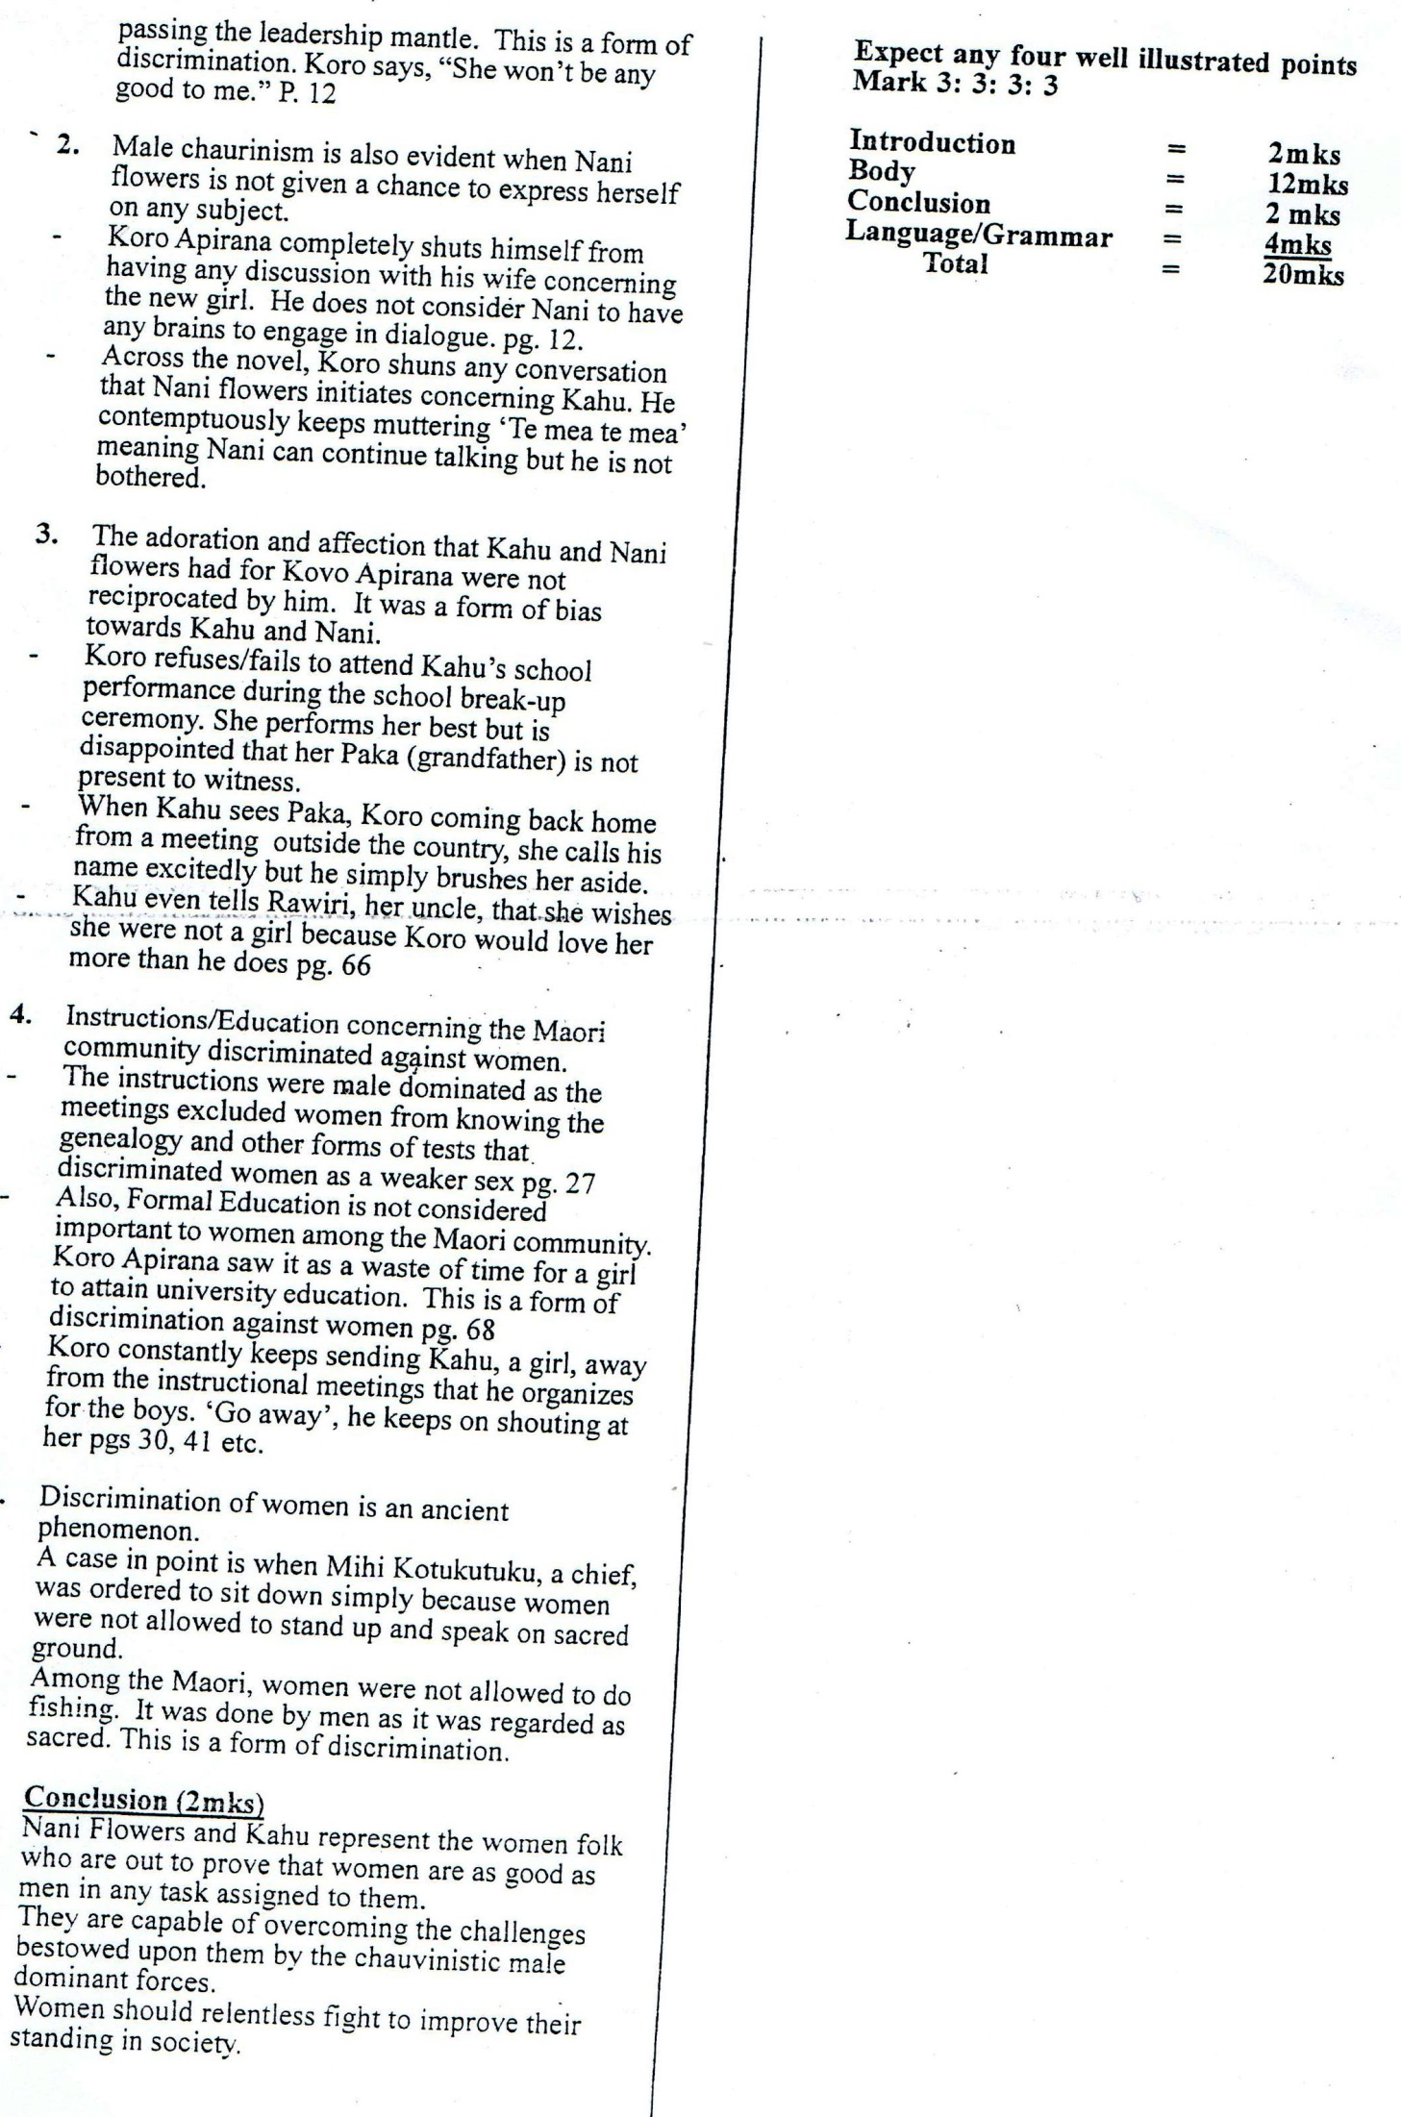 Basing your illustrations from the text.*The Whale Rider* by Witi Thimaera, **show how gender discrimination has been brought out**

**RACIAL DISCRIMINATION**

This refers to discrimination that is based on skin complexion. This mainly happened at Papua New Guinea where Rawiri had relocated to with Jeff having come from Australia.

When they arrived at Jeff’s home, his parents are informed that Rawiri was a Maori. But they find too dark. Rawiri says that he could almost hear Clara, Jeff’s mother, wondering how she would explain him to other women at the Bridge Club.

After staying for some time at Papua New Guinea, Jeff’s parents start pushing him out gently. They felt that Rawiri was supposed to consult with his own kind in the clubs and all parties of the expatriates. This throws Rawiri more to the company of the natives. According to the whites In Papua New Guinea, he had broken a cardinal rule and the punishment was ostracism.

At one time, the family gets invited to a reception hosted at Port Moresby for a young expatriate couple who had wed. Claranaturally assumed that Rawiri would be left to watch the plantation. Jeff insisted that he should go as he was one of the family. Clara made it obvious that she was embarrassed by Rawiri’s presence. Rawiri is saddened to her say to another guest, “he’s a friend of Jeff’s. You know our Jeff, always bringing home dogs and strays. But at least he’s not a native.”(pg 58).

When Jeff runs over Bernard, their own worker, the family has no qualms leaving him on the road, injured. When Rawiri tries to move out to help him, he is told by Clara to leave him alone – because he was only a native! Tom himself told Rawiri to try to “understand”. Jeff whimpers and starts the car.

When Rawiri forcefully yanks the door open, Clara yells to Jeff to leave him there and that is what they do. When the inquest is done, the verdict was that: it was an accident, of course. A native walking carelessly on the side of the road. And it could have happened to anybody. Rawiri wondered whether he would be the next. Within a month he leaves the country and went back to New Zealand.

**FAMILY RELATIONS**

The author gives prominence to family and family relationships in the story. The Maori tribe is said to have originated from a mystical man from the sea. This man was Kahutia Te Rangi and his “spears” that ensured family stability. Koro Apirana and Nani Flowers run their homestead with a firmness that holds the family together.

Porourangi, the oldest grandson of Koro, stays outside the city but maintains a close touch with the family back home. He keeps on informing them about his new family development. He calls to tell them of the birth of his first born, a girl Kahu. Everybody celebrates except Koro Apirana who wanted a boy for a great grand child to be the custodian of Maori culture.

Family relations are heightened when Kahu’s afterbirth and birth cord are brought to be buried in her ancestral home. This is to reconcile her with Whangara people, her father’s family. The cord is picked by Nani Flowers and the boys from the airport and buried in front of the meeting house.

The naming of children also strengthens family relations. Rehua named the child after their ancestor, Kahutia Te Rangi, so that if she (Rehua) died the child would be linked to her father’s people and land. Her birth cord is buried on the earth Marae, their village since Kahu has Porourangi and Old Paikea’s blood.

Family relationship is further developed through the characters in the story. Rawiri purposely narrates to us the mutual relationship between the extended family members. He reveals the deep bond of love and culture holding the family together.no wonder Porourangi who is staying in South Island updates his family of his developments. Rawiri also communicates with his family while in diaspora.

At the end of the story even Koro Apirana who had not appreciated Kahu because of being a girl, embraces her as “the best grandchild in the whole wide world, boy or girl, it doesn’t matter…” (pg 121).

**BETRAYAL**

This is the act of betraying someone who trusts you. The ancient whale together with the golden master had established a very close relationship ever since the golden master rescued the whale when it was small.

One day Kahutia Te Rangi requested the ancient whale to accompany him to take gifts of Hawaiki to the people of Whangara. While there the golden master gets married and starts a family. He tells the whale to return to the kingdom of Tangaroa and live with his own kind. The whale felt betrayed by the golden master for bringing to an end the close relationship they had…the heartache of the separation has never left the whale… (pg 77).

Koro Apirana betrayed Kahu by failing to acknowledge her just because she was a girl. The moment she was born, he got disgusted and said that he will have nothing to do with her. Although Kahu craves for his love, Koro pushes her away at every opportunity he gets. As a girl, Kahu is of use to Koro Apirana. (pg 10, 91).

When Jeff hit a man (Bernard) on the road and leaves him for dead, Rawiri who had treated him a best friend feels betrayed. It pained Rawiri that a friend he had could react to the assumptions of his culture. He wondered whether he would be the next victim. This is one of the events that made him start thinking of going back home.